Basic assignment mongodp

1)

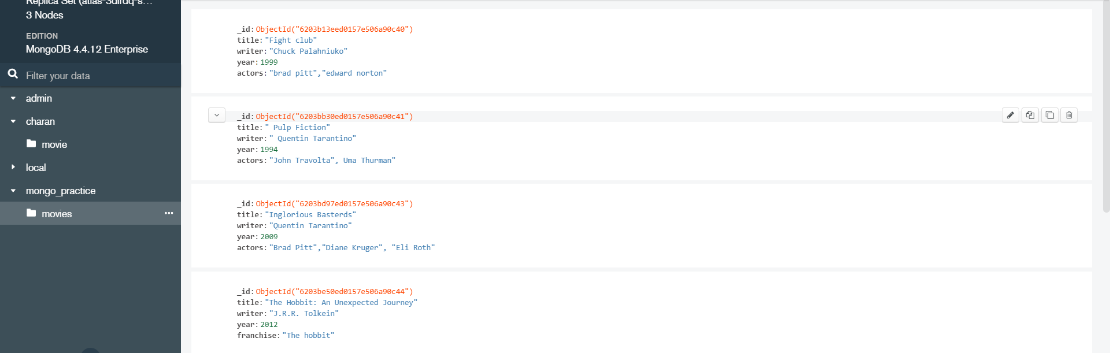

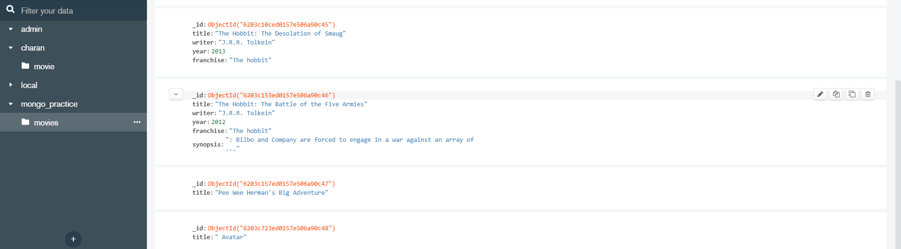

2)

get all documents with writer set to "Quentin Tarantino"

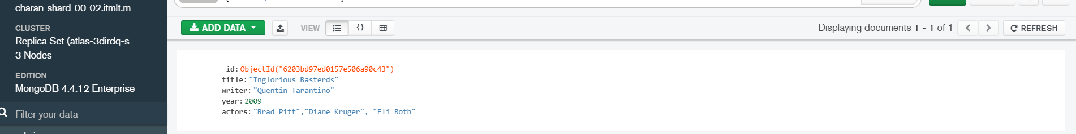

get all documents with franchise set to "The Hobbit"

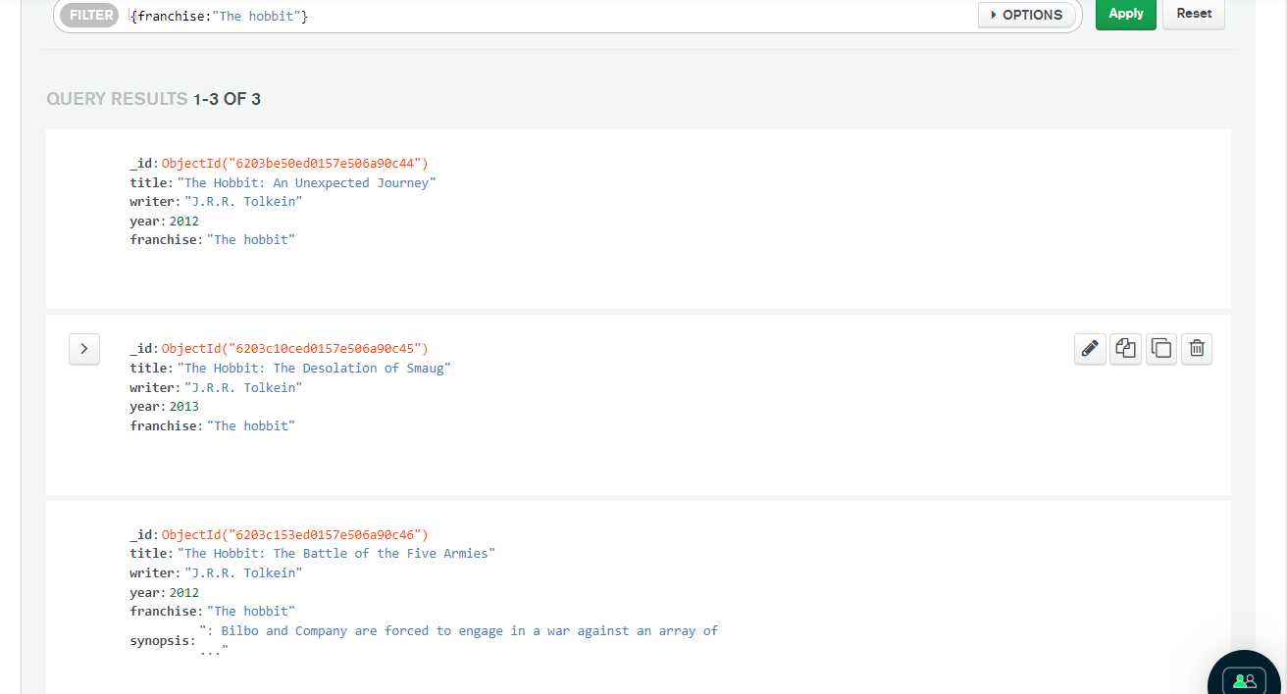

get all movies released in the 90s

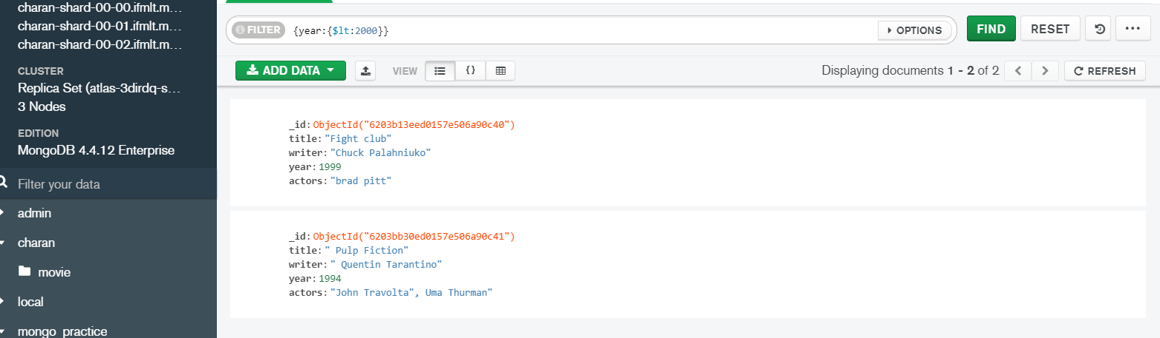

get all movies released before the year 2000 or after 2010

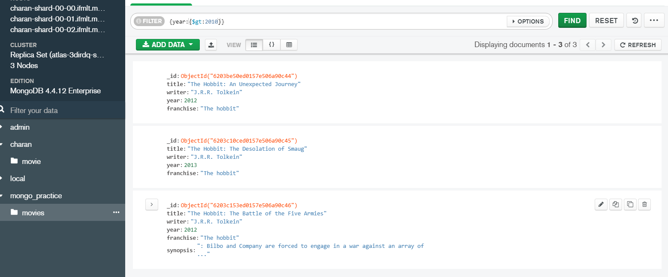

**Update Documents**

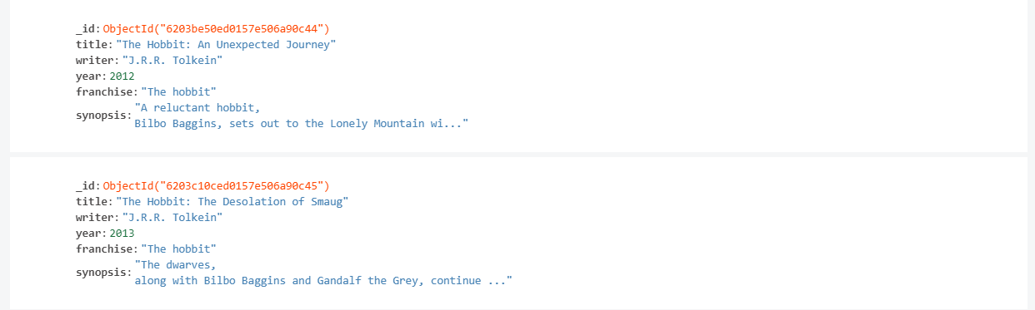

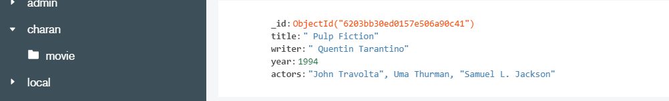

Name search

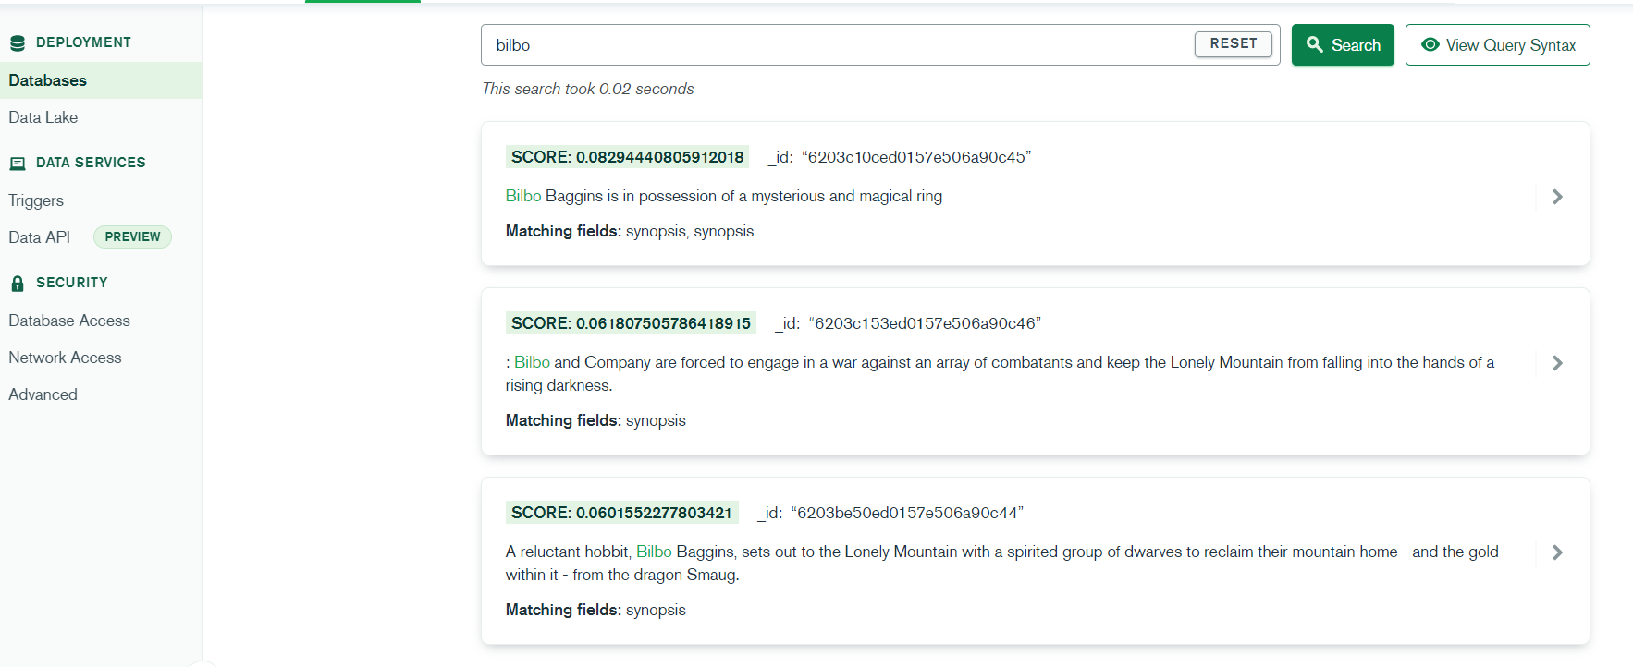

3)

all user

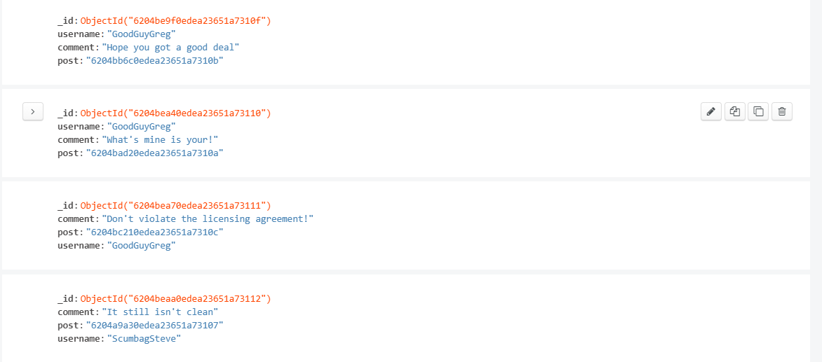

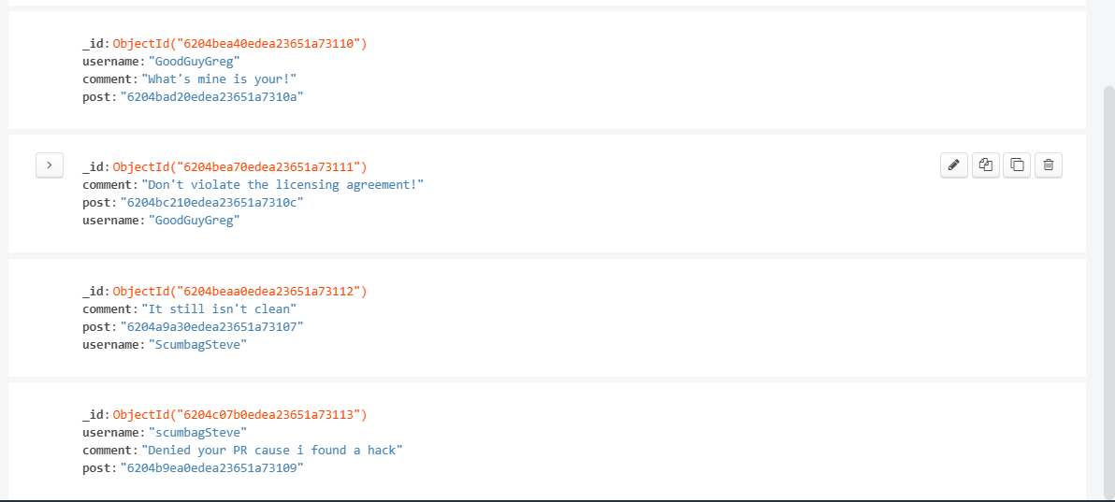

Post by GoodGuyGreg

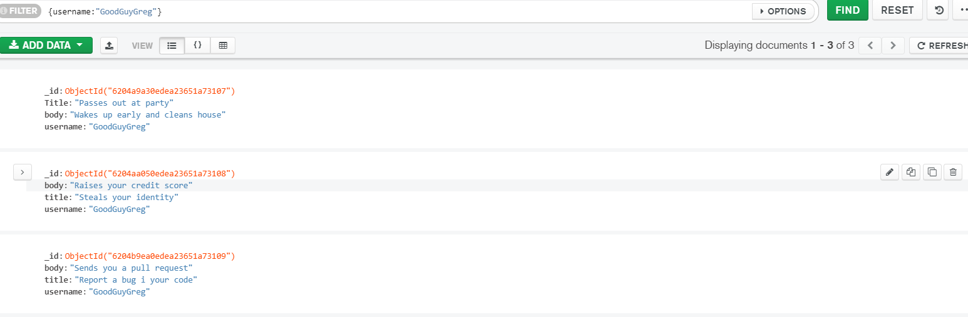

Post by scumbag steve

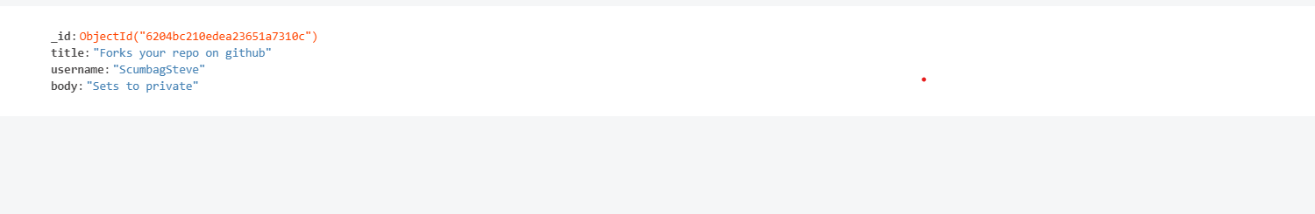

Comment by goodguygreg

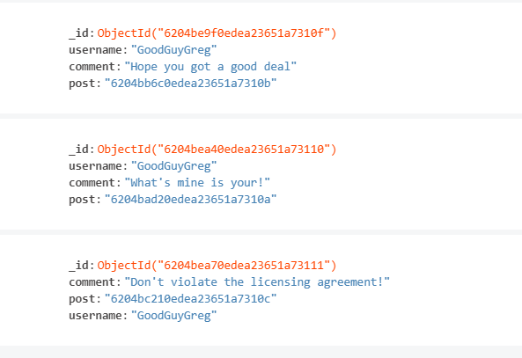

Comment by scumbagsteve

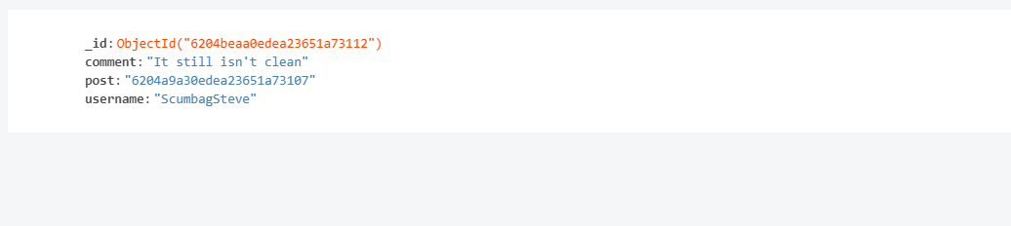

Mongodb assignment aggregation

Population in atlanta

use db.zipcodes.find() to filter results to only the results where city is ATLANTA

and state is GA.

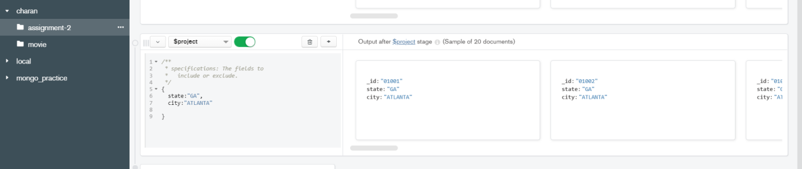

use $match

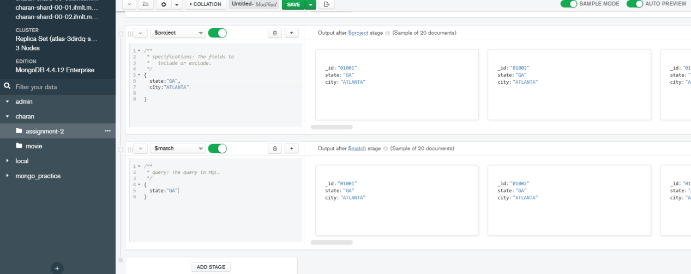

Total population of atlanta

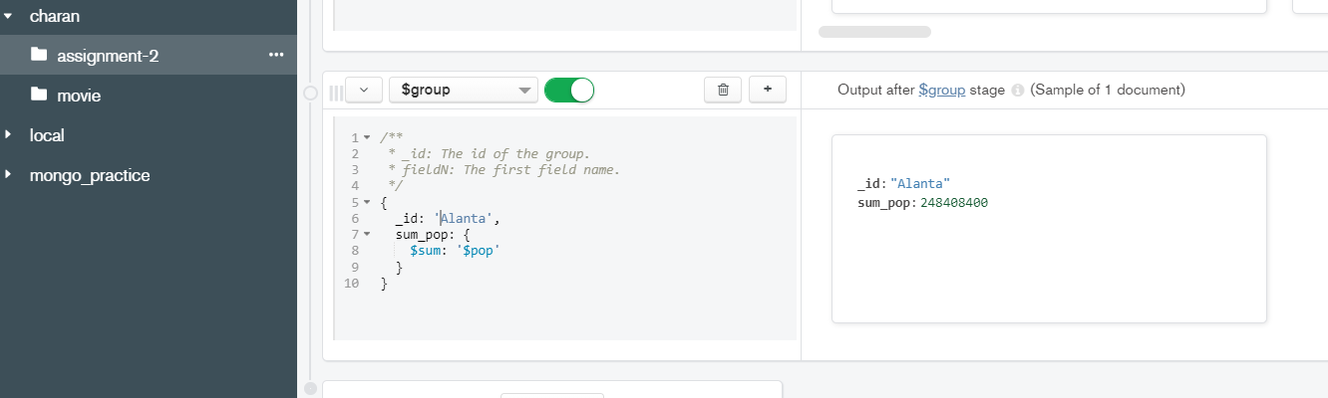

Population by state

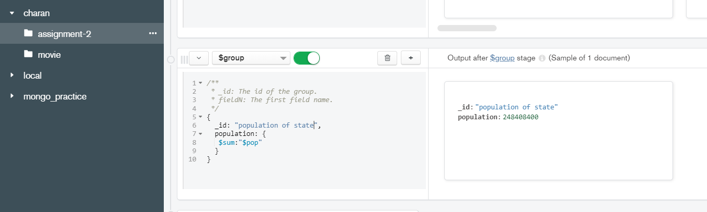

Populated stated

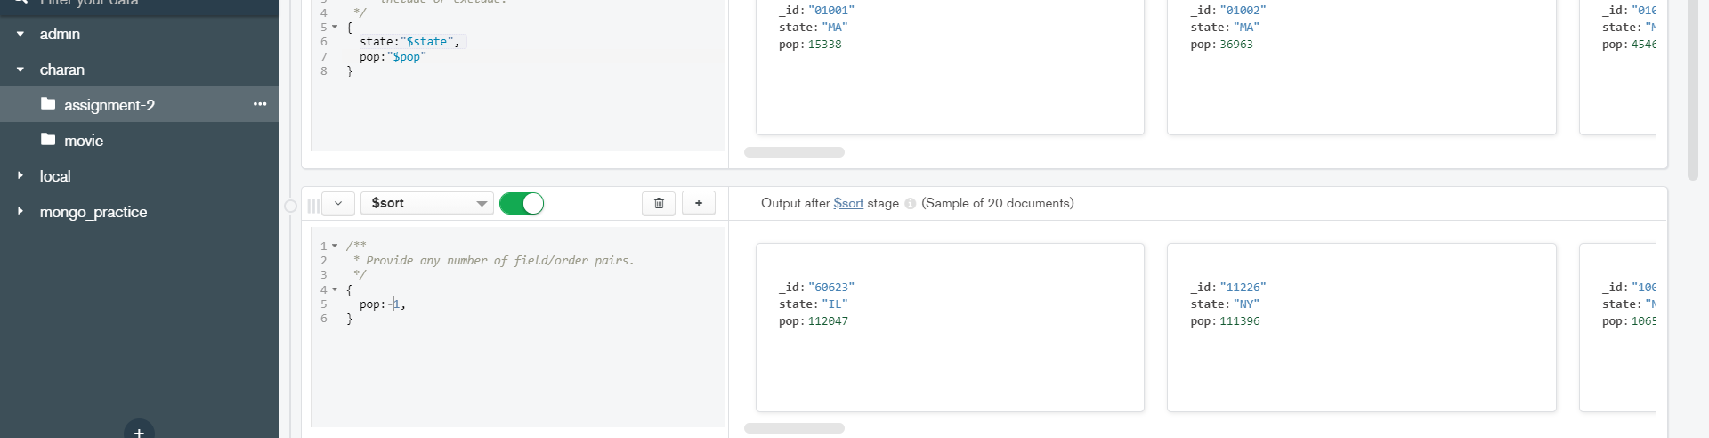

Population by highest 3

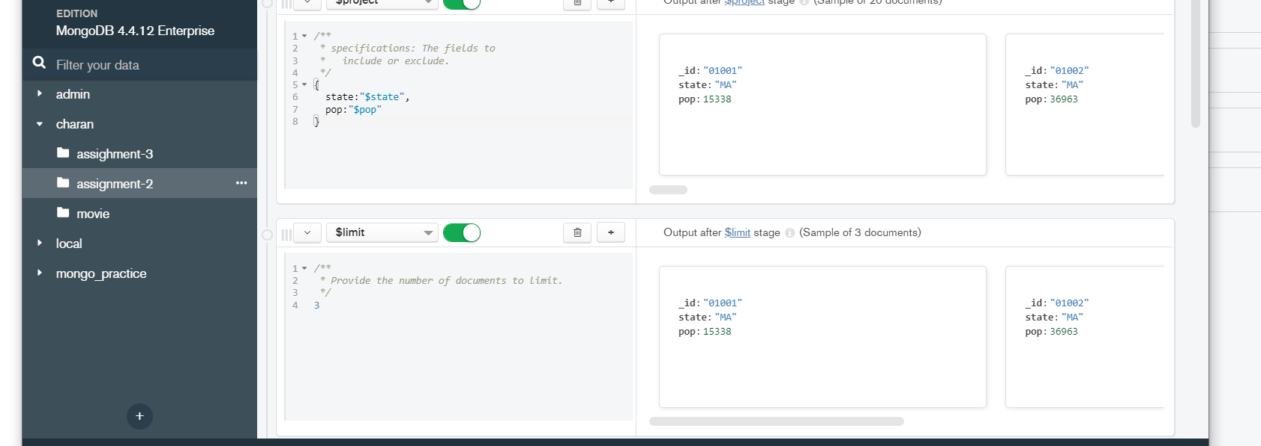

Population by city

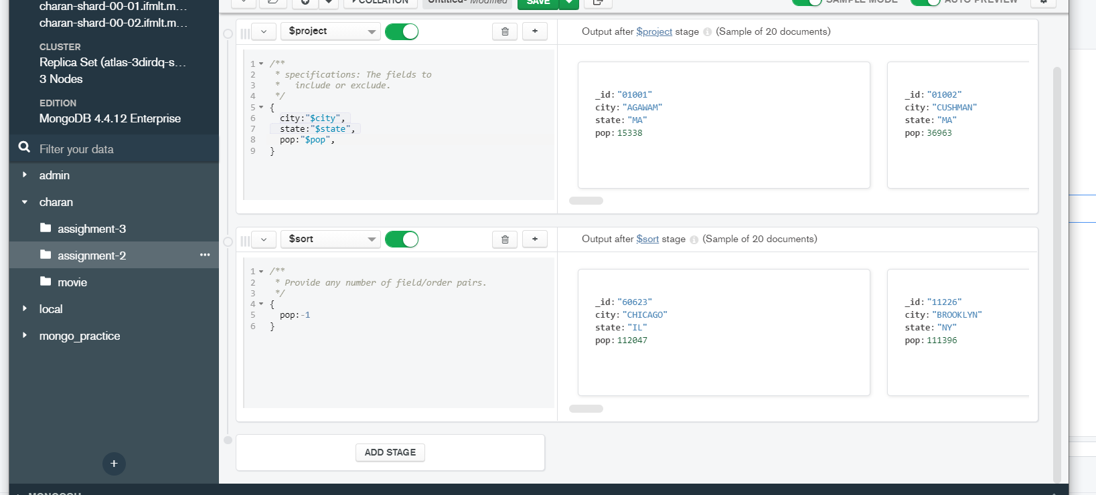

Limit by 3 biggest city

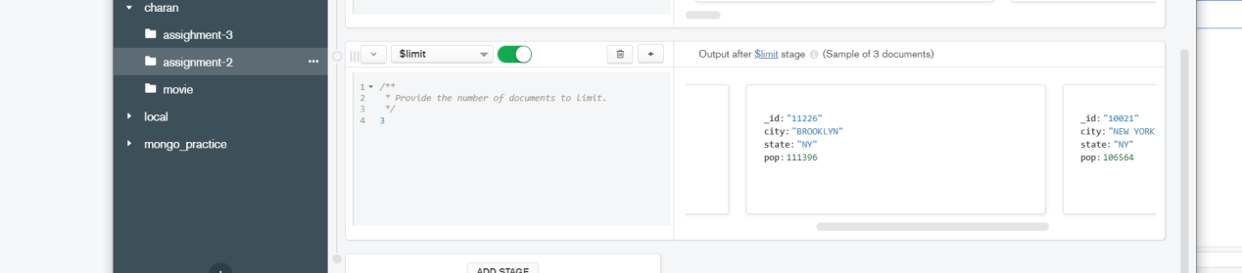

Top 3 biggest city in texas

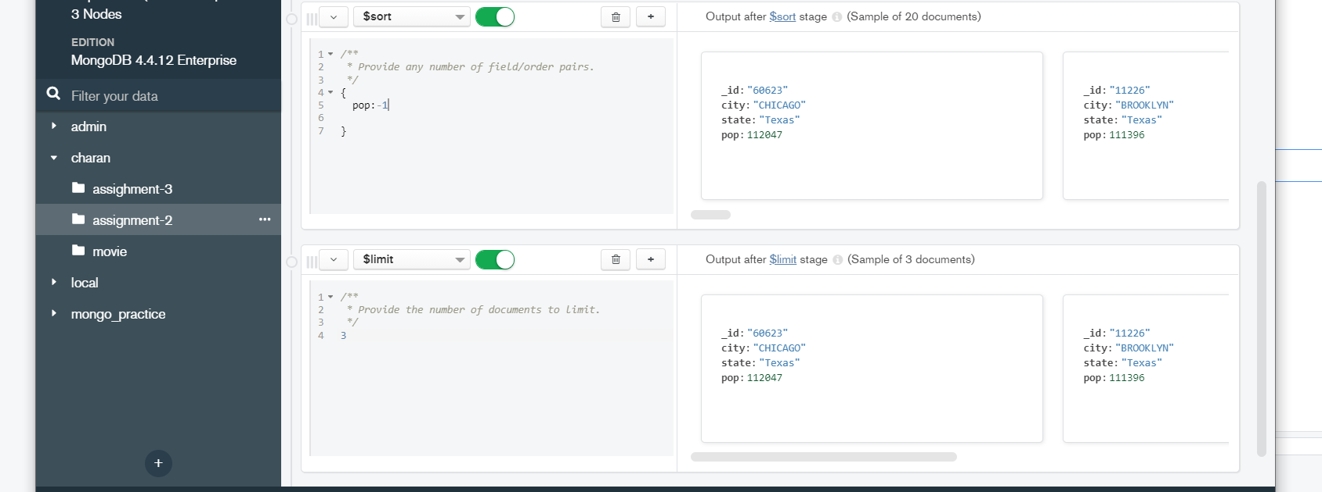

Avg of state

